

**Vehicle Platform Software**



Next Generation

Telematics Platform

Software Requirements Specification

*Version – 1.1*

*2018/11/09*

Table of Contents

1

Next Generation 1

1. Revision History 4

1.1. Change List Details 4

2. Introduction 5

2.1. Document Purpose and Scope 6

2.2. Document Audience 6

2.3. Definitions, Acronyms, Abbreviations 6

2.4. References 6

3. System Scope Definitions 7

4. Vehicle Types 7

5. Software Functions by Vehicle Type 7

6. Data Acquisition by Vehicle Type 8

7. Overall System Architecture 9

8. Software System Architecture Overview 9

8.1. Block Diagram 10

9. System Software Architecture Details 12

9.1. Embedded LINUX operating system (boot loader, kernel, BSP) 12

9.1.1. Secure Boot – uboot 12

9.1.2. Signed Kernel 12

9.1.3. SELinux 12

9.2. BSP Interfaces and Drivers 12

9.2.1. CAN Drivers 12

9.2.2. K-Line Drivers 12

9.2.3. GNSS / GPS 12

9.2.4. WiFi 13

9.2.5. BT 13

9.2.6. BLE 13

9.2.7. USB 13

9.2.8. Security Device 13

9.2.9. Radio (WWAN Modem) 13

9.2.10. Gyro / Accelerometer 13

9.2.11. Digital I/O 13

9.2.12. Analog I/O 14

9.2.13. SIM/eSIM 14

9.2.14. eMMC / Storage 14

9.2.15. RS232 14

9.3. Vehicle Telematics API 15

9.3.1. Vehicle interface (J1939, OBDII, K-Line, UDS) 15

9.3.2. MQTT for vehicle and event topics 16

9.3.3. MQTT also used for IPC on the system 17

9.3.4. ConnectAll API (control for BLE and USB) 17

9.3.5. AIS-140 Requirements 18

9.4. Application Space 19

9.4.1. OTA Software Update and Management 19

9.4.2. ECU OTA Update Process 19

9.4.3. UDS Diagnostics 22

9.4.4. System OTA Manager for device software 23

9.4.5. Alerts 23

10. System Diagnostics Software 23

10.1. Power-on Self Test 23

10.2. Command Line Diagnostics 23

11. Software Rights and Exclusivity 23

Appendix 1 Data Structures 25

a) Packet Information (Header) 25

b) GPS Data Elements 25

c) Radio / WWAN Elements 26

d) AL Vehicle - Common Parameters 26

e) AL Engine – Common CAN Parameters (CAN) 27

f) AL Sensor Data 27

g) AL Engine – Specific CAN Parameters (CAN) 28

h) AL Vehicle – Specific Parameters (BCU, CAN) 28

i) AL Vehicle – Type Specific Unique Parameters (CAN) 29

# Revision History

|  |  |  |  |  |
| --- | --- | --- | --- | --- |
| Version | Revision Description | Date Revised | Sections Revised | Author |
| 1.0 | First draft | 2018/10/30 | All | Kjell Erickson |
| 1.1 | Completed Integration | 2018/11/05 | Many | Kjell Erickson |
| 1.2 | Identify Phases 1 and 2 | 2018/11/09 | Phase table and colorization | Kjell Erickson |

## Change List Details

Version 1.0

1. All New

Version 1.1

1. Added content from multiple sources: AL documents, HW matrix, PCG DOxygen, OS Spec, hardware docs, sw matrix, and others.
2. Substantial content and organizational changes.
3. There are still numerous sections which need completion or partial input to be complete

Version 1.1

1. Section 3: Added Table breaking down SW efforts for Phase 1 and 2
2. Various: Colorized section headers where appropriate for Phase 1 and 2 where Green is Phase 1, Purple is Phase 2.

# Introduction

The Trimble Desi Telematics Platform is an on-board telematics system for medium and heavy duty commercial trucks and buses based on truck platforms. The system is integrated into the vehicle and provides a wide range of services: location, data collection, communications, diagnostics, reporting, Bluetooth data streaming, software updates, ECU software updates, alerts, etc.

The Desi will be fully compliant with AIS140 regulatory functions for passenger applications.

The target vehicles for this product are all existing and future AL vehicle platforms including Diesel and Electric/Hybrid versions.

The Desi will integrate these functions as shown in the diagram below:

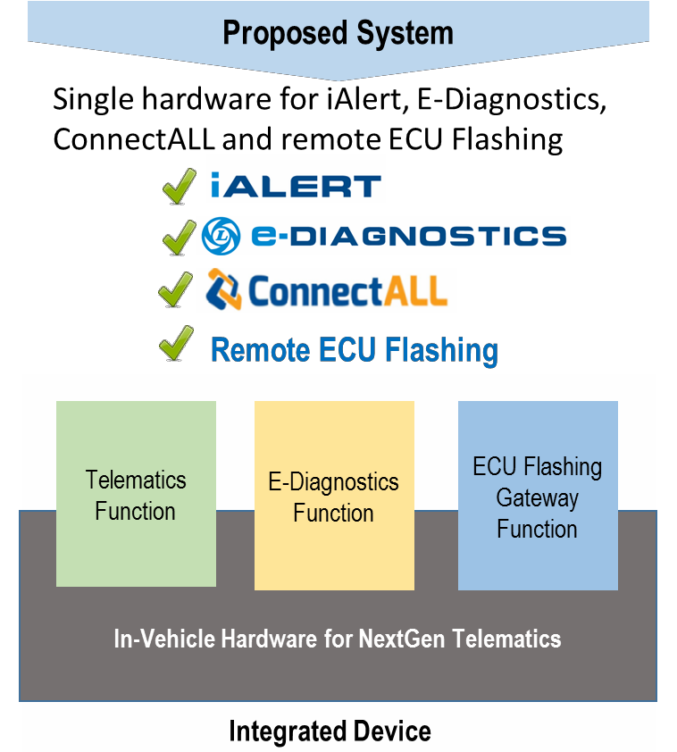

*Figure 1*

The following table defines the AL systems components shown in the diagram.

|  |  |
| --- | --- |
|  | AL’s OE Telematics solution intended for connecting the 3C’s – Customer, Channel, and Company |
|  | A Mobile based application intended for AL’s Mechanic/Dealer/Service personnel for diagnosing and finding error codes in Electronic Control Units in a vehicle via Bluetooth from the telematics system. |
|  | A laptop based advanced diagnostic application, which features ECU diagnostics, Guided Troubleshooting, ECU Flashing and Data logging. The Laptop shall be connected to the vehicle via Bluetooth or USB. |

Table 1 – AL Systems Components

## Document Purpose and Scope

The purpose of this document is to describe the Software Requirements for the Trimble Desi Telematics Platform. The content is limited to the software that runs directly on the device itself.

Interface functions and protocols for host side communications are addressed completely, but specific implementation details regarding host communications pipelines or mechanisms are not in scope for this specification.

All other ‘local’ communications functions and protocols (USB, Serial, WiFi, Bluetooth, etc.) will be described fully in this document.

## Document Audience

The audience for this document is the software engineering teams at Trimble and Innominds.

This document is not a user manual, but a description of how the system software is architected and how it operates. Requirements (specifically the package and component requirements) for the system Board Support Package (BSP) will be specified in a separate document to provide to the BSP vendor. See section on BSP Requirements below.

## Definitions, Acronyms, Abbreviations

|  |  |
| --- | --- |
| **Term** | **Definitions** |
| Bluetooth | Specification for a wireless communication to replace cabling, also known as IEEE 802.15.1 |
| BLE | Bluetooth Low Energy |
| BSP | Board Support Package – the port of the OS to the hardware platform |
| CPU | Central Processing Unit |
| Gb | Gigabit – a unit of computer memory consisting of 1,073,741,824 bits |
| GB | Gigabyte - a unit of computer memory consisting of 1,073,741,824 bytes |
| GPS | Global Positioning System. A space-based satellite navigation system that provides location and time information anywhere on or near the earth |
| I/O | Input / Output |
| ISO | International Standards Organization |
| LED | Light Emitting Diode |
| Mb | Megabit – a unit of computer memory consisting of 1,048,576 bits |
| MB | Megabyte – a unit of computer memory consisting of 1,048,576 bytes |
| OBC | On-board Computer (typically telematics gateway) |
| OTG | USB On The Go, a specification that allows USB devices to act as a host |
| RAM | Random Access Memory |
| RTC | Real Time Clock |
| S3 | Amazon Simple Cloud Storage Service (Simple Storage Service) |
| SAE | Society of Automotive Engineers – specification names from SAE are typically formatted as “J1455” |
| TBD | To Be Determined – an item in the document that will defined at a later date |
| USB | Universal Serial Bus – a high speed serial interface that has role dependent connectors |
| VTP | Trimble’s Vehicle Telematics Platform system |
| WAN | Wide Area Network – LTE/GSM |
| WiFi | A wireless communication mechanism over a computer/electronic devices network. It uses the IEEE 802.11 family of standard |

Table 2 - Definitions

## References

|  |
| --- |
| **Title** |
| *AIS-140 Final Draft – May 2017* |
| *J2534_1_201510 Surface Vehicle Recommended Practice for Pass Through Vehicle Programming* |
| *J2534_2_201010 Surface Vehicle Recommended Practice – Optional Pass Through Features* |
| *J2534_200202 Surface Vehicle Recommended Practice – Pass Through Vehicle Programming* |

Table 3 - References

# System Scope Definitions

|  |  |  |  |
| --- | --- | --- | --- |
| **Phase 1** | **SOW** | **Phase 2** | **SOW** |
| Secure boot | 1 | USB support | 1 |
| Signed Kernel | 1 | RS232 support (High precision fuel, TPMS, RFID) | 1 |
| SELinux | 1 | ECU OTA (SW and Parameters) | 1 |
| System/BSP/Drivers | 1 | ECU UDS Diagnostics Support (run and clear) | 1 |
| System diagnostic application | 1 | Support for eDiagnostics (streaming on Bluetooth) | 2 |
| AIS-140 compliance | 1 | Support for ConnectAll | 2 |
| Deliver of AL Backend Periodic Data | 2 | External Sensors (section 6) | 2 |
| Desi System Update OTA | 1 | CAN Protocol: J1939 | 2 |
| Security device driver\support | 1 | CAN Protocol: UDS | 2 |
| GNSS (GPS, IRNSS) | 1 | K-Line | 2 |
| CAN Drivers | 1 | Bluetooth | 1 |
| CAN protocol: OBDII (CAN) (Vehicle Data) | 2 | BLE | 1 |
| Digital I/O | 1 | Analog I/O | 1 |
| Gyro / Accelerator | 1 |  |  |
| Radio support (modem manager) | 1 |  |  |
| SIM/eSIM | 1 | WiFi | 1 |
| eMMC | 1 |  |  |
| RS232 | 1 |  |  |
| MQTT | 2 |  |  |
| Lighttpd | 2 |  |  |

Table 4 – Phase Scope

# Vehicle Types

The table below indicates the types of vehicles the Desi platform will support.

|  |  |  |  |
| --- | --- | --- | --- |
| Item | Type | Power | Description |
| 1 | EDC | 12 and 24 VDC | BS4 vehicles of AL |
| 2 | EEA | 24 VDC | EE architecture based BS4 vehicles of AL |
| 3 | BS6 EDC | 12 and 24 VDC | BS6 vehicles of AL (from Apr 2020) |
| 4 | BS6 EEA | 24 VDC | EE architecture based BS6 vehicles of AL (from Apr 2020) |
| 5 | EV | 24 VDC | EE architecture based EV vehicles of AL |
| 6 | OBDII | 12 and 24 VDC | OBDII compliant vehicles |

Table 5 – Vehicle Types

1. The data source format varies by vehicle type
2. Desi shall auto detect the vehicle type
3. Desi will support static setting of vehicle type (as default)
4. Vehicle type operation to be mutually agreed upon by Trimble and AL.

# Software Functions by Vehicle Type

This table indicates the Desi software functions available by vehicle type. While the table indicates identical requirements for all vehicle types besides OBDII, the actual parameter sets may vary by vehicle.

|  |  |  |  |  |  |  |
| --- | --- | --- | --- | --- | --- | --- |
|  | **Desi Software Functions** | | | | | |
| **Vehicle Type** | **Telemetry Periodic** | **ConnectAll API (BLE & USB)** | **AIS-140** | **ECU OTA**  **Software** | **ECU OTA Parameter** | **ECU Diagnostics and Clear** |
| EDC | ✔ | ✔ | ✔ (Buses Only) | ✔ | ✔ | ✔ |
| EEA | ✔ | ✔ | ✔ (Buses Only) | ✔ | ✔ | ✔ |
| BS6 EDC | ✔ | ✔ | ✔ (Buses Only) | ✔ | ✔ | ✔ |
| BS6 EEA | ✔ | ✔ | ✔ (Buses Only) | ✔ | ✔ | ✔ |
| EV | ✔ | ✔ | ✔ (Buses Only) | ✔ | ✔ | ✔ |
| OBDII | ✔ | ✔ | ✔ (Buses Only) | n/a | n/a | n/a |

Table 6 – SW Functions by Vehicle Type

# Data Acquisition by Vehicle Type

This table indicates the Desi data acquisition categories required by vehicle type.

|  |  |  |  |  |  |  |  |
| --- | --- | --- | --- | --- | --- | --- | --- |
|  | **Data Acquisition Categories** | | | | | | |
|  | GNSS | CAN |  | | | | |
| Vehicle Type | Fuel Level | Low Oil Pressure | Low Air Pressure | RPM | External Fuel Level |
| EDC | ✔ | ✔ | ✔ | ✔ | ✔ | ✔ | ✔ |
| EEA | ✔ | ✔ | n/a | n/a | n/a | ✔ | ✔ |
| BS6 EDC | ✔ | ✔ | n/a | n/a | n/a | ✔ | ✔ |
| BS6 EEA | ✔ | ✔ | n/a | n/a | n/a | ✔ | ✔ |
| EV | ✔ | ✔ | n/a | n/a | n/a | n/a | n/a |
| OBDII | ✔ | ✔ | n/a | n/a | n/a | n/a | ✔ |

Table 7 – Data Acquisition by Vehicle Type

# Overall System Architecture

The overall architecture of the system is described in the following diagram:

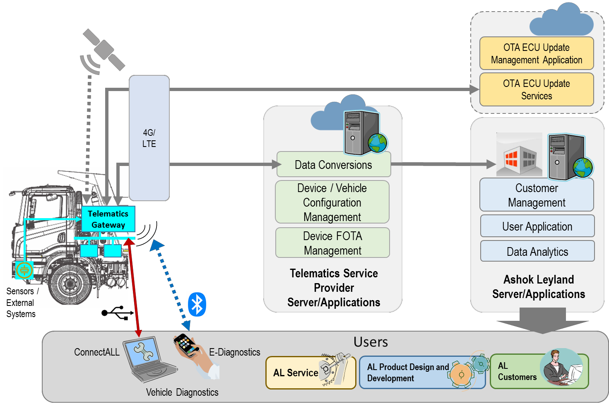

*Figure 2 – Overall System Architecture*

The Desi Telematics Platform is shown in this illustration as Telematics Gateway. It is installed on the vehicle and connected to the vehicle bus network and sensors.

GPS, LTE, and I/O connections are provided in the vehicle.

Bluetooth, WiFi, and USB connectivity is provided on the system for external applications shown.

4G/LTE interface connects to:

* Trimble back end system via TDMG
* OTA ECU Update management server
* Trimble back end systems provide services and data to AL server applications

E-Diagnostics application connects to Desi via Bluetooth interface.

ConnectALL Advanced Diagnostic Application connects to Desi via either USB or Bluetooth.

# Software System Architecture Overview

The software system for the Desi Telematics Platform is a layered architecture as shown in the SW Architecture Diagram below. These layers are described below and in the diagram.

The diagram also indicates the areas of software responsibility for the project. Innominds is primarily responsible for the system software. Trimble Vehicle Platform SW team will collaborate with Innominds on the Telematics API and Application software.

A detailed description of the components follows the Desi SW Architecture diagram below:

## Block Diagram

The block diagram below is a simplified architectural view of the components in the Desi system software. They are broken out by assignment of responsibility between Trimble and Innominds.

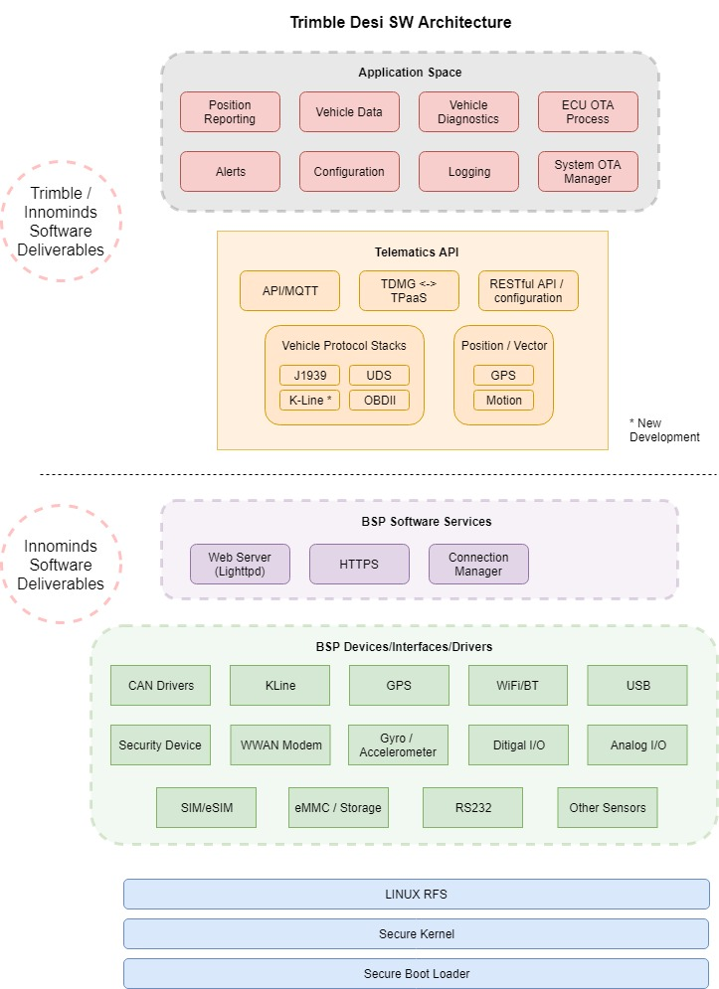

*Figure 3 – Trimble Desi Software Architecture*

# System Software Architecture Details

## Embedded LINUX operating system (boot loader, kernel, BSP)

### Secure Boot – uboot

### Signed Kernel

### SELinux

## BSP Interfaces and Drivers

### CAN Drivers

**CAN Bus Speeds**

The following table shows the CAN Bus speeds by Matrix

|  |  |
| --- | --- |
| **Speed** | **Matrix** |
| 250 Kbps | CAN Matrix A |
| 250 Kbps | CAN Matrix B |
| 500 Kbps | CAN Matrix A + Delta Y |
| 500 Kbps | CAN Matrix C |
| 250 Kbps | CAN Matrix B + Delta Y |
| 250/500/other | OBDII PIDs |

Table 8 – CAN Bus Speeds

**CAN Channels**

CAN Channel 1 – Telemetry Data Acquisition

CAN Channel 2 – UDS Services – Diagnostics, Flashing, Parameter Update, etc.

**CAN Speed Detection**

1. CAN Baud rate for each channel shall be auto-selected at system initialization time, and saved.
2. CAN Baud rate for each channel will be auto-selected after every system restart.
3. All auto-detected CAN baud rates (per channel) will be stored in system memory.
4. Stored CAN Baud rate values are to be used at every Ignition On event.

### K-Line Drivers

#### Input functionality

#### Output functionality

### GNSS / GPS

1. GPS subsystem will be connected into gpsd
2. GPS Handler function will parse information from gpsd
3. GPS Data structure is filled and internal/external topics for GPS are populated
   * The system shall produce GPS readings on a configurable interval:   
     500 mS, 1 S (default), or 5 S

### WiFi

### BT

### BLE

|  |  |  |
| --- | --- | --- |
| Purpose | **Sensor Type** | **Remarks** |
| **Driver identification (beacon card)** | BLE |  |
| **Tire pressure monitoring system** | BLE |  |

Table 9 – BLE Connections

### USB

Desi will support a USB connection for the ConnectAll application to perform diagnostics and flashing operations.

Support for the SAE J2534 protocol is required for these operations

### Security Device

Ability to read available data from security device is required for Phase 1 of the project.

Use of the X.509 certificate for TLS is Phase 2.

### Radio (WWAN Modem)

### Gyro / Accelerometer

### Digital I/O

#### Inputs

1. Desi supports a total of 4 digital Input signals with configurable selection of high/low state.
2. Software will be configurable from host to select input state.
3. One input needs to be configured as a frequency input (interrupt?) (1-5 kHz)
4. Frequency input needs enable/disable configuration
5. Sensors supported:

|  |  |  |
| --- | --- | --- |
|  | **Sensor Type** | **Remarks** |
| **Low Oil Pressure** | Active Low |  |
| **Low Air Pressure** | Active Low |  |
| **RPM** | Frequency | TBD |

Table 10 – Sensors Supported

1. RPM sensor must use configurable alternator pulley constant ratio

#### Outputs

1. Desi supports a total of 4 digital Output signals
2. Maximum 400mA current output
3. Sensors supported:

|  |  |  |
| --- | --- | --- |
|  | **Sensor Type** | **Remarks** |
| **Buzzer** | Pulsed | Interrupt ? |
| **AIS-140** |  |  |
| **Immobilizer Relay** | Active State? |  |
| **Ignition Relay** | Active State? |  |

Table 11 – Digittal Output Devices

### Analog I/O

1. Desi supports a total of 2 analog Input signals with a measurement range of 0 – 12V.
2. One of these analog inputs will be dedicated to a resistive type fuel level sensor. (0-300 ohms)
3. Sensors supported:

|  |  |  |
| --- | --- | --- |
|  | **Sensor Type** | **Remarks** |
| **Fuel Level** | Analog | Convert to Fuel Level |

Table 12 – Analog Input Devices

1. Fuel level must be subject to calibration and conversion lookup formulae provided by the backend system
2. This calibration record must be stored on the Desi device
3. Fuel sensor type must also be configurable

### SIM/eSIM

### eMMC / Storage

### RS232

Desi will support 1 RS232 interface for connection to external sensors. Some examples of these sensor types are defined in the table below.

|  |  |  |
| --- | --- | --- |
|  | **Sensor Type** | **Remarks** |
| **External Fuel Level** | RS232 / CAN |  |
| **Tire pressure monitoring system** | RS232 / CAN |  |
| **Identification systems RFID based** | RS232 |  |

Table 13 – RS232 Input Devices

External Fuel Level Sensor

* Optional equipment
* Recommended by AL
* Configurable by back end system
* Calibration separate from other fuel level sensor
* Specification to be shared

## Vehicle Telematics API

### Vehicle interface (J1939, OBDII, K-Line, UDS)

#### CAN Periodic Data Acquisition

1. Data shall be read from CAN bus as per J1939 Application layer specification. The PGNs shall be standard or proprietary based on the vehicle type configured.
2. CAN Matrix for each type provided in Appendix A.
3. Data shall be requested (for specific parameters only) and read from vehicle CAN bus as per CAN Matrix specification specific to vehicle types.
4. The CAN parameters shall be received and processed as per the specified repetition rate. However, the parameters shall be stored in the internal data structure based on the sampling interval configured.
5. Valid intervals are in multiple of 5 second increments only (e.g. 5, 10, 30, 60)
6. A special higher frequency sampling interval of less than 5 seconds shall also be supported. This will be referred to as a special sample type, with the interval also configurable. This data type will be published as a different OBC sample type – to differentiate it from the normal data sample type.
7. The recommended parameter list is provided in Appendix A. The parameter list shall be mutually discussed and agreed.
8. There shall be reserved parameter fields protected for adding new parameters in the future. The configuration shall be in such a way that the system shall process and send new parameters in reserved fields when the CAN Matrix specification is updated in the device configuration.
9. Can periodic data is published at a configurable interval.

#### CAN DM1 Data Acquisition

1. Apart from periodic CAN data processing, the system shall decode single packet and multi-packet DM1 messages (Diagnostics Messages). The DM1 messages shall be interpreted as per J1939-Diagnsotics.
2. The system shall be capable of processing a single multi-packet message consisting of up to 50 diagnostics codes.
3. Decoded DM1 messages shall be packaged in alert packet structure (1 alert message for one diagnostics code) and shall be pushed to backend
4. The source ECU ID, Diagnostics Code and Occurrence Count shall be decoded from each
5. DM1 message for constructing the alert message
6. At every IGN ON, all DM1 messages shall be interpreted and alerts shall be send to backend. The system shall remember the alerts send after an IGN ON and shall not send duplicate alerts in the same IGN cycle.

#### CAN OBDII Data Acquisition

1. In the OBDII mode, the system shall request for standard OBDII PIDs and decode the values.
2. The default list of OBDII PIDs is found in Appendix A.

### MQTT for vehicle and event topics

1. MQTT is the preferred protocol for exchange of information from Desi to back-end applications
2. Other protocols may also be of value (TCP, HTTP, HTTPS, etc.) and will be evaluated for their efficacy
3. Data security will be employed (TLS encryption) for all communications between Desi and back-end
4. Topics will be generated to match the various periodic reporting data structures defined in Appendix A
5. All topical data will be in JSON format.
6. Normalization of the topical data parameters is the responsibility of the back-end software except where explicitly noted
7. Back-end systems will subscribe to topical data published by Desi, normalize the data, and transmit the data to AL in the AL Unified Packet Structure
8. AL’s unified packet structure is a superset of the periodic data structures listed in Appendix A

### MQTT also used for IPC on the system

### ConnectAll API (control for BLE and USB)

Desi shall provide an api for communicating / exchanging information to an external host device vie BLE or USB. The following table lists the eligible host devices and connectivity:

|  |  |  |
| --- | --- | --- |
| **Connection** | **Host Device** | **Purpose** |
| Bluetooth (BLE) | Mobile Phones | Custom app development |
| Bluetooth (BLE) | Tablets | Custom app development |
| USB (J2534) | Laptop / PC | Diagnostics and flashing services |
| USB | Laptop / PC | Flashing device software |

Table 14 – ConnectAll Connectivity

Desi ConnectAll API shall:

1. Include HW configuration functions for managing devices, settings
2. API available via BLE
3. API to setup BLE operational mode
4. CAN Pass through mode
5. Pure OBDII mode
6. API available on USB to support configuration of and support for the J2534 Pass-through Vehicle Programming.
7. See references table for external SAE J2534 Specifications.
8. The API specification shall be developed exclusively for AL.
9. AL Intends to standardize on the API specification.

#### BLE SSID

1. Comprised of the DSN and a unique prefix: <prefix> + <DSN>
2. Trimble to propose prefix to AL for approval along with final format

#### API Functions

The following table defines the API functions required for the BLE and USB interfaces.

All APIs will have pre-define return values for each function – where applicable

|  |  |
| --- | --- |
|  | **Hardware Specific APIs** |
| 1 | Initiate connections to interface hardware |
| 2 | Configure channel settings (CAN, K-Line, Baud rate, etc.) |
|  | **Application Level APIs - BLE** |
| 1 | Set filters for message identifiers or sources |
| 2 | Receive CAN data |
| 3 | Send CAN data |
| 4 | Set the mode to OBDII |
| 5 | Receive / Send data in OBDII Mode |
| 6 | Receive K-LINE data |
| 7 | Send K-LINE data |
|  | **Application Level APIs – USB (J2534)** |
| 1 | Perform ECU Diagnostics |
| 2 | Perform ECU Diagnostic Clear |
| 3 | Perform Actuator Tests |
| 4 | Perform Set Parameters |
| 5 | Perform Flashing Operation |

Table 15 – ConnectAll API Requirements

### AIS-140 Requirements

1. AIS 140 functions are applicable only for bus models of the vehicle types listed in   
   Table 4 – Vehicle Types
2. All requirements specified in the following two documents are completely met:
   * *AIS140 - Intelligent Transportation Systems (ITS) - Requirements for Public Transport Vehicle Operation*
   * *Amendment 1 (11th December 2017) To AIS-140: Intelligent Transportation Systems (ITS) - Requirements for Public Transport Vehicle Operation*
3. AIS-140 functionality may be enabled/disabled via configuration from the back-end system
4. By default, AIS-140 support is disabled
5. AIS-140 compliance requires certification / approval with the government test agency
6. Trimble and AL will obtain vehicle certification

## Application Space

### OTA Software Update and Management

1. The Telematics Gateway software update shall be managed by TSP
2. There shall be a failsafe mechanism to update the software of the Telematics Gateway remotely and it shall be managed by TSP.
3. There shall be a provision to mass update the software in all devices in the field
4. There shall be mechanisms with TSP to check the Telematics Gateway software update status / generate reports on the software update status centrally.
5. The software updates shall be triggered to field devise only after concurrence from AL.

### ECU OTA Update Process

1. The Desi shall engage in the OTA ECU Update process in response to a valid notification trigger from the OTA application running on the Vehicle Update Server.  
     
   The following diagram shows the functional blocks of the OTA ECU process.

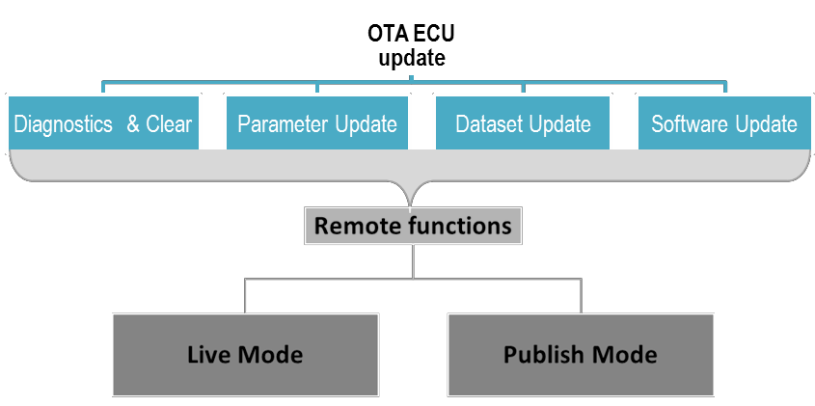

*Figure 4 – ECU OTA Process Block Diagram*

1. The ECU OTA update process utilizes APIs provided by the ECU OTA Update Server.  
   These APIs include:
   * getSecurityKey
   * updateStatus
   * sendDiagnosticsSummary
   * ???
2. UDS Protocol stack over CAN is utilized for performing
   * Diagnostics Scan
   * Diagnostics Clear
   * Adjust/update parameter
   * Flash ECU
3. Pre-conditions for ECU update shall be agreed upon between AL and Trimble
4. Desi allows for cancelling a schedule ECU OTA operation if prompted vi notification from the Update Server
5. Status updates will be provided during ECO OTA Update operations including:
   * Downloading Dataset/Software
   * Flashing in progress (% completion)
   * Flashing success
   * Flashing failed (error code)
6. AL and Trimble will agree upon the status update sequence for each update function
7. Desi will download and store the Master Configuration File from the Update Server
8. This Master Configuration describes the processes for performing OTA ECU Updates
9. Master Configuration file shall be encrypted XML
10. AL and Trimble mutually agree upon format and content for the Master Configuration file

#### ECU Diagnostics and Diagnostic Clear

1. Desi will engage the UDS Diagnostics process upon receipt of a diagnostics request notification from the Update Server.
2. System will send Read DTC query to all ECUs per Master Configuration file
3. Desi shall clear ECU security unlock via Security Access Service hosted at the ECU OTA Update Server.
4. Desi shall obtain seeds from the target ECU and invoke the appropriate service at the AL server to obtain the key for clearing security access to the target ECU.
5. Read DTC query performed with read freeze frame (if applicable for the ECU based on Master Configuration)
6. Read diagnostics with freeze frame shall be posted to services at AL OTA server and the diagnostics session shall be closed with ECUs.
7. Based clear DTC notification from AL OTA Update server, the Telematics Gateway shall establish a UDS session to target ECU (Clear security as explained above, if applicable) and send clear DTC request to target ECUs via UDS over CAN.
8. The Telematics gateway shall update status of various stages of OTA ECU Update functions to server.

#### ECU Parameter Update

1. Desi will engage the Parameter Update process upon receipt of a notification from the Update Server.
2. Based on parameter update request / notification from server, the Telematics gateway shall perform parameter update to target ECU/s in-line with ECU diagnostics master configuration.
3. Based on ECU diagnostics master configuration, Telematics ECU shall clear security unlock (If applicable) in co-ordination with Security Access Service hosted in OTA ECU Update server. The Telematics Gateway shall obtain the seed/seeds from target ECU and call the appropriate service at AL server to obtain the key for clearing security access to target ECU.
4. The Telematics gateway shall update status of various stages of OTA ECU Update functions to server.

#### ECU Dataset/Software Update

1. Desi will engage the Dataset/Software Update process upon receipt of a notification from the Update Server.
2. Based on dataset/software update request / notification from server, the Telematics gateway shall request dataset/software and flash sequence of the target ECU via OTA ECU Update services at appropriate scenario. The right scenario to download the software to Telematics gateway shall be mutually discussed and agreed (e.g When LTE with good signal strength, vehicle is not running etc…)
3. Once the download is complete, the Telematics gateway shall prepare to flash the target ECU at appropriate scenario. The right scenario to flash the software to target ECU shall be mutually discussed and agreed (e.g. when vehicle is not running, isolator is switched off, etc…)
4. Based on ECU diagnostics master configuration, Telematics ECU shall clear security unlock (If applicable) in co-ordination with Security Access Service hosted in OTA ECU Update server. The Telematics Gateway shall obtain the seed/seeds from target ECU and call the appropriate service at AL server to obtain the key for clearing security access to target ECU.
5. The Telematics gateway shall check the dataset/software version of target ECU and compare with the one downloaded to internal memory.
6. If the versions are different, then the Telematics gateway shall flash the target ECU and the % of competition shall be updated to server via OTA ECU Update services in fixed intervals.
7. If the versions are same, then the Telematics gateway shall skip flashing and communicate to server that the target ECU dataset/software version and requested version are same.
8. After successful flashing, Telematics gateway shall read the dataset/software part number from target ECU and check for successful update.
9. On successful flashing, the downloaded dataset/software shall be deleted from internal memory
10. The exceptions to be handled by the Telematics Gateway
11. The Telematics gateway shall update status of various stages of OTA ECU Update functions to server.

### UDS Diagnostics

#### Read DTC

1. The telematics gateway system shall support critical diagnostics codes
2. The diagnostics code list shall be proposed by TSP and approved by AL for implementation
3. AL shall enable scan/diagnostics tool support for field diagnostics of the telematics gateway

#### Read Live Data

1. The telematics gateway system shall support live data parameters
2. The live data parameter list shall be discussed and agreed for implementation
3. AL shall enable scan/diagnostics tool support for field diagnostics of the telematics gateway
4. The tentative live data list is provided below

#### EOL Testing

1. The Telematics gateway shall support UDS live data as per the requirement given so that AL shall build the end of line tool support in the mobile based application.
2. EOL test parameters shall be mutually discussed and agreed.

### System OTA Manager for device software

Insert content from OTA process document for PCG

### Alerts

1. An alert shall be generated when a desired condition is met
2. Alerts can be generated both on the Desi and on the back-end
3. Definition of alerts shared in separate alert specification

# System Diagnostics Software

## Power-on Self Test

## Command Line Diagnostics

# Software Rights and Exclusivity

1. The discussed software architecture and process flow shall be developed exclusively for AL and AL shall own the rights on the same.
2. To be further discussed add updated

Appendix 1 Data Structures

The data structures defined by the AL Requirements are contained in this Appendix.

The implication from the AL requirements indicates all parameter structures are concatenated following the packet information and transmitted as a single packet. The decision for Desi is to migrate to and expand the Delta Comms interface at TDMG as the preferred means of host communications. Topical data will be published by Desi using the MQTT protocol to Delta Comms. The monolithic nature of the AL data packet is deconstructed into the various topical structures the device will report from the field. The Data structures below are references and descriptive only.

All topical data published by Desi will be in JSON format. The Delta Comms interface will normalize and assemble the data elements that will be relayed to AL’s back-end systems.

1. Packet Information (Header)

The Packet Information – header information – is define in the following structure

|  |  |  |  |  |  |  |  |  |
| --- | --- | --- | --- | --- | --- | --- | --- | --- |
| **Parameter** | **Units** | **Description** | **EDC (BS4)** | **EEA (BS4)** | **BS6 EDC** | **BS6 EEA** | **OBDII** | **EV** |
| Packet Info | String | Supplier Specific | ✔ | ✔ | ✔ | ✔ | ✔ | ✔ |
| Packet type | String | RS and OS | ✔ | ✔ | ✔ | ✔ | ✔ | ✔ |
| Vehicle Type | String | TBD | ✔ | ✔ | ✔ | ✔ | ✔ | ✔ |
| Packet Seq # | Number | Sequence Number | ✔ | ✔ | ✔ | ✔ | ✔ | ✔ |
| Checksum | Number | Packet Checkesum | ✔ | ✔ | ✔ | ✔ | ✔ | ✔ |
| Others | - | TBD | ✔ | ✔ | ✔ | ✔ | ✔ | ✔ |

1. GPS Data Elements

The system shall provide the following information from the GPS system.

|  |  |  |  |  |  |  |  |  |
| --- | --- | --- | --- | --- | --- | --- | --- | --- |
| **Parameter** | **Units** | **Description** | **EDC (BS4)** | **EEA (BS4)** | **BS6 EDC** | **BS6 EEA** | **OBDII** | **EV** |
| DSN | String | Device Serial Number | ✔ | ✔ | ✔ | ✔ | ✔ | ✔ |
| Timestamp | Seconds | (Unix Epoch) (GMT) | ✔ | ✔ | ✔ | ✔ | ✔ | ✔ |
| Latitude | Degrees |  | ✔ | ✔ | ✔ | ✔ | ✔ | ✔ |
| Longitude | Degrees |  | ✔ | ✔ | ✔ | ✔ | ✔ | ✔ |
| Altitude | Meters | Meters above Sea Level | ✔ | ✔ | ✔ | ✔ | ✔ | ✔ |
| Heading | Degrees / 2 | Vehicle heading in 2 degree granularity (ex: 124=248 deg) | ✔ | ✔ | ✔ | ✔ | ✔ | ✔ |
| GPS fix status | string | “none”, “good” | ✔ | ✔ | ✔ | ✔ | ✔ | ✔ |
| Number of Satellites | Number | Number of sattellites currently connected to Desi | ✔ | ✔ | ✔ | ✔ | ✔ | ✔ |
| GPS speed | Km/h | Speed calculated by GPS engine | ✔ | ✔ | ✔ | ✔ | ✔ | ✔ |
| GPS Distance | Km | Accumulated GPS distance since event. | ✔ | ✔ | ✔ | ✔ | ✔ | ✔ |
| Dilution of Precision (DoP) | Number | <1 Ideal; 1-2 Excellent; 2-5 Good; 5-10 Moderate; 10-20 Fair; >20 Poor | ✔ | ✔ | ✔ | ✔ | ✔ | ✔ |

1. Radio / WWAN Elements

This table indicates the Desi reported data for the wireless link to the host system.

Note this collection of wireless link status messages exceeds the required fields defined by AL, but is the standard reporting structure for Trimble Telematics Devices produced by the Vehicle Platform Team.

|  |  |  |  |  |  |  |  |  |
| --- | --- | --- | --- | --- | --- | --- | --- | --- |
| **Parameter** | **Units** | **Description** | **EDC (BS4)** | **EEA (BS4)** | **BS6 EDC** | **BS6 EEA** | **OBDII** | **EV** |
| DSN | String | Device Serial Number | ✔ | ✔ | ✔ | ✔ | ✔ | ✔ |
| Timestamp | Seconds | (Unix Epoch) (GMT) | ✔ | ✔ | ✔ | ✔ | ✔ | ✔ |
| Tech | String | “2G”, “3G”, “4G”, “unknown” | ✔ | ✔ | ✔ | ✔ | ✔ | ✔ |
| State | String | “connected”, “searching”, “limitedService” | ✔ | ✔ | ✔ | ✔ | ✔ | ✔ |
| MCC | String | Mobile Country Code (first part of PLMN) | ✔ | ✔ | ✔ | ✔ | ✔ | ✔ |
| MNC | String | Mobile Network Code (second part of PLMN) | ✔ | ✔ | ✔ | ✔ | ✔ | ✔ |
| RSRP | String | Ref Signal Receive Pwr | ✔ | ✔ | ✔ | ✔ | ✔ | ✔ |
| RSRQ | String | Ref Signal Receive Qual | ✔ | ✔ | ✔ | ✔ | ✔ | ✔ |
| GlobalCellID | String | 4G Global Cell ID | ✔ | ✔ | ✔ | ✔ | ✔ | ✔ |
| PhysicalCellID | String | 4G Physical Cell ID | ✔ | ✔ | ✔ | ✔ | ✔ | ✔ |
| RSCP | String | Receive Sig Code Pwr | ✔ | ✔ | ✔ | ✔ | ✔ | ✔ |
| ECNO | String | Carrier to Noise ratio in dB | ✔ | ✔ | ✔ | ✔ | ✔ | ✔ |
| CELL | String | 2G, 3G Cell ID | ✔ | ✔ | ✔ | ✔ | ✔ | ✔ |
| LAC | String | 2G, 3G Location area code | ✔ | ✔ | ✔ | ✔ | ✔ | ✔ |
| BCCH | String | BCCH Carrier receive level in dBm | ✔ | ✔ | ✔ | ✔ | ✔ | ✔ |
| DBM | String | Traffice channel receive level in dBm | ✔ | ✔ | ✔ | ✔ | ✔ | ✔ |
| QUAL | String | Receiving quality 0-7 | ✔ | ✔ | ✔ | ✔ | ✔ | ✔ |
| QualNumber | Number | All tech reveive quality 0-7, 7 being excellent | ✔ | ✔ | ✔ | ✔ | ✔ | ✔ |

1. AL Vehicle - Common Parameters

AL specifically requires a set of vehicle data with is in large part a subset of the overall vehicle data supported by the Trimble Vehicle Telematics Platform (VTP) code.

While standard vehicle data topics are already created and reported by the VTP, it may be desirable to produce new topical data structures to contain only those parameters required by AL (in addition to the standard VTP reporting structures. This will require an expansion of the Delta Comms API to accommodate these new topical structures.

The following table specifically outlines the requested AL data structures (new topical structures).

|  |  |  |  |  |  |  |  |  |
| --- | --- | --- | --- | --- | --- | --- | --- | --- |
| **Parameter** | **Units** | **Description** | **EDC (BS4)** | **EEA (BS4)** | **BS6 EDC** | **BS6 EEA** | **OBDII** | **EV** |
| DSN | String | Device Serial Number | ✔ | ✔ | ✔ | ✔ | ✔ | ✔ |
| Timestamp | Seconds | (Unix Epoch) (GMT) | ✔ | ✔ | ✔ | ✔ | ✔ | ✔ |
| IGN Status |  |  | ✔ | ✔ | ✔ | ✔ | ✔ | ✔ |
| Vehicle Speed |  |  | ✔ | ✔ | ✔ | ✔ | ✔ | ✔ |
| Telematics backup battery voltage |  |  | ✔ | ✔ | ✔ | ✔ | ✔ | ✔ |
| Vehicle battery voltage |  |  | ✔ | ✔ | ✔ | ✔ | ✔ | ✔ |
| Driver ID (TBD) |  |  | ✔ | ✔ | ✔ | ✔ | ✔ | ✔ |
| Others (TBD) |  |  | ✔ | ✔ | ✔ | ✔ | ✔ | ✔ |

1. AL Engine – Common CAN Parameters (CAN)

The following table outlines the AL Specific Common CAN Parameters desired.

|  |  |  |  |  |  |  |  |  |
| --- | --- | --- | --- | --- | --- | --- | --- | --- |
| **Parameter** | **Units** | **Description** | **EDC (BS4)** | **EEA (BS4)** | **BS6 EDC** | **BS6 EEA** | **OBDII** | **EV** |
| DSN | String | Device Serial Number | ✔ | ✔ | ✔ | ✔ | ✔ | n/a |
| Timestamp | Seconds | (Unix Epoch) (GMT) | ✔ | ✔ | ✔ | ✔ | ✔ | n/a |
| Engine speed | Number | Km/H | ✔ | ✔ | ✔ | ✔ | ✔ | n/a |
| Engine coolant temp | Number | Degrees C | ✔ | ✔ | ✔ | ✔ | ✔ | n/a |
| Total fuel consumption | Number | # of liters consumed since event | ✔ | ✔ | ✔ | ✔ | ✔ | n/a |
| Accel Pedal Pos | Number | % Accelerator Pedal Position | ✔ | ✔ | ✔ | ✔ | ✔ | n/a |
| Actual engine torque | Number | % Actual engine torque | ✔ | ✔ | ✔ | ✔ | ✔ | n/a |
| Total engine hours of operation | Number | Total engine run hours since event | ✔ | ✔ | ✔ | ✔ | ✔ | n/a |
| Nominal friction % torque | Number | Nominal friction a % of torque | ✔ | ✔ | ✔ | ✔ | n/a | n/a |

1. AL Sensor Data

The following table outlines the AL Specific Sensor Data desired.

|  |  |  |  |  |  |  |  |  |
| --- | --- | --- | --- | --- | --- | --- | --- | --- |
| **Parameter** | **Units** | **Description** | **EDC (BS4)** | **EEA (BS4)** | **BS6 EDC** | **BS6 EEA** | **OBDII** | **EV** |
| DSN | String | Device Serial Number | ✔ | ✔ | ✔ | ✔ | n/a | n/a |
| Timestamp | Seconds | (Unix Epoch) (GMT) | ✔ | ✔ | ✔ | ✔ | n/a | n/a |
| Digital IN 1 | String | “High” or “Low” | ✔ | ✔ | ✔ | ✔ | n/a | n/a |
| Digital IN 2 | String | “High” or “Low” | ✔ | ✔ | ✔ | ✔ | n/a | n/a |
| Digital IN 3 | String | “High” or “Low” | ✔ | ✔ | ✔ | ✔ | n/a | n/a |
| Digital IN 4 | String | “High” or “Low” | ✔ | ✔ | ✔ | ✔ | n/a | n/a |
| Analog IN 1 | Number | Analog voltage level | ✔ | ✔ | ✔ | ✔ | n/a | n/a |
| Analog IN 2 | Number | Analog voltage level | ✔ | ✔ | ✔ | ✔ | n/a | n/a |
| RS232 Data | String | TBD | ✔ | ✔ | ✔ | ✔ | n/a | n/a |
| Others (TBD) | ? | Variable string | ✔ | ✔ | ✔ | ✔ | n/a | n/a |

1. AL Engine – Specific CAN Parameters (CAN)

The AL Engine - Specific CAN parameters are listed in the following table.

|  |  |  |  |  |  |  |  |  |
| --- | --- | --- | --- | --- | --- | --- | --- | --- |
| **Parameter** | **Units** | **Description** | **EDC (BS4)** | **EEA (BS4)** | **BS6 EDC** | **BS6 EEA** | **OBDII** | **EV** |
| DSN | String | Device Serial Number | ✔ | ✔ | ✔ | ✔ | n/a | n/a |
| Timestamp | Seconds | (Unix Epoch) (GMT) | ✔ | ✔ | ✔ | ✔ | n/a | n/a |
| Engine Oil Pressure | Number | PSI | ✔ | ✔ | ✔ | ✔ | n/a | n/a |
| Engine Oil Temp | Number | Degrees C | ✔ | ✔ | ✔ | ✔ | n/a | n/a |
| Vehicle Distance | Number | Km | ✔ | ✔ | ✔ | ✔ | n/a | n/a |
| Engine Intake Manifold 1 pressure | Number | PSI | ✔ | ✔ | ✔ | ✔ | n/a | n/a |
| Clutch Status | String | ? | ✔ | ✔ | ✔ | ✔ | n/a | n/a |
| Brake Status | String | ? | ✔ | ✔ | ✔ | ✔ | n/a | n/a |
| Engine Coolant Level | String | ? | n/a | n/a | ✔ | ✔ | n/a | n/a |
| Engine Oil Level | String | ? | n/a | n/a | ✔ | ✔ | n/a | n/a |
| Barometric Pressure | Number | mm/Hg | n/a | n/a | ✔ | ✔ | n/a | n/a |
| Ambient Air Temp | Number | Degrees C | n/a | n/a | ✔ | ✔ | n/a | n/a |
| Engine exhaust gas temp | Number | Degrees C | n/a | n/a | ✔ | ✔ | n/a | n/a |
| Engine particulate trap inlet pressure | Number | PSI | n/a | n/a | ✔ | ✔ | n/a | n/a |
| Software ID | String | Software Revision number | n/a | n/a | ✔ | ✔ | n/a | n/a |
| Engine total idle fuel used | Number | Liters | n/a | n/a | ✔ | ✔ | n/a | n/a |
| Engine total idle hours | Number | Hours | n/a | n/a | ✔ | ✔ | n/a | n/a |
| Others (TBD) | ? | ? | n/a | n/a | ✔ | ✔ | n/a | n/a |

1. AL Vehicle – Specific Parameters (BCU, CAN)

The AL Vehicle Specific Parameters are listed in the table below.

|  |  |  |  |  |  |  |  |  |
| --- | --- | --- | --- | --- | --- | --- | --- | --- |
| **Parameter** | **Units** | **Description** | **EDC (BS4)** | **EEA (BS4)** | **BS6 EDC** | **BS6 EEA** | **OBDII** | **EV** |
| DSN | String | Device Serial Number | ✔ | ✔ | ✔ | ✔ | ✔ | ✔ |
| Timestamp | Seconds | (Unix Epoch) (GMT) | ✔ | ✔ | ✔ | ✔ | ✔ | ✔ |
| ODO – Instrument | Number | Odometer from Instrument cluster | n/a | ✔ | ✔ | ✔ | n/a | ✔ |
| Battery charging current | Number | Amperes | n/a | ✔ | ✔ | ✔ | n/a | n/a |
| Brake Air Pressure  (Circuit 1) | Number | PSI | ✔ | ✔ | ✔ | ✔ | n/a | ✔ |
| Brake Air  Pressure  (Circuit 2) | Number | PSI | ✔ | ✔ | ✔ | ✔ | n/a | ✔ |
| Fuel Level | Number | Liters | ✔ | ✔ | ✔ | ✔ | n/a | n/a |
| Distance to Empty | Number | Km | n/a | ✔ | ✔ | ✔ | n/a | n/a |
| Parking Brake | String | “On” or “Off” | n/a | ✔ | ✔ | ✔ | n/a | ✔ |
| Trailer indicator switch | String | “Connected” or “Disconnected” | n/a | ✔ | ✔ | ✔ | n/a | n/a |
| PTO switch | String | “Engaged” or “Disengaged” | n/a | ✔ | ✔ | ✔ | n/a | n/a |
| Gear compliance | String | “Yes” or “No” | n/a | ✔ | ✔ | ✔ | n/a | n/a |
| MBP Reserved 1-10 | ? | TBD | n/a | n/a | n/a | ✔ | n/a | n/a |

1. AL Vehicle – Type Specific Unique Parameters (CAN)

The

|  |  |  |  |  |  |  |  |  |
| --- | --- | --- | --- | --- | --- | --- | --- | --- |
| **Parameter** | **Units** | **Description** | **EDC (BS4)** | **EEA (BS4)** | **BS6 EDC** | **BS6 EEA** | **OBDII** | **EV** |
| DSN | String | Device Serial Number | n/a | n/a | n/a | n/a | n/a | ✔ |
| Timestamp | Seconds | (Unix Epoch) (GMT) | n/a | n/a | n/a | n/a | n/a | ✔ |
| EV Param 1 | ? | TBD | n/a | n/a | n/a | n/a | n/a | ✔ |
| EV Param 2 | ? | TBD | n/a | n/a | n/a | n/a | n/a | ✔ |
| EV Param 50 | ? | TBD | n/a | n/a | n/a | n/a | n/a | ✔ |